26.85: a) We will say that a capacitor is discharged if its charge is less than that of one electron, The time this takes is then given by:
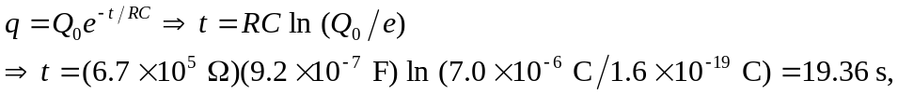
or 31.4 time constants.
b) As shown in (a), 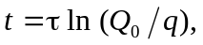 and so the number of time constants required to discharge the capacitor is independent of 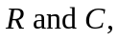 and depends only on the initial charge.

